Short report about peer-to-peer learning in Sopron, Hungary from 13.11.2017 to 15.11.2017.
Employees of the Samara State University of Economics Mikhail Nazarov and Roman Fedorenko together with representatives of the universities of Russia and Kazakhstan took part in a short peer-to-peer learning from 13.11.2017 to 15.11.2017 at the University of Sopron, Hungary. The learning took place as a part of the international project Enhancement of Higher Education and Corporate Sectors Integration in Accordance with the New Social Environment (ENINEDU). Alexandre Lamfalussy Faculty of Economics was the main host for the training, the speakers were the dean of the faculty, university professors and invited experts. The schedule of events included lectures, discussions, visiting of university partners and workshops, which took place every day of our training.

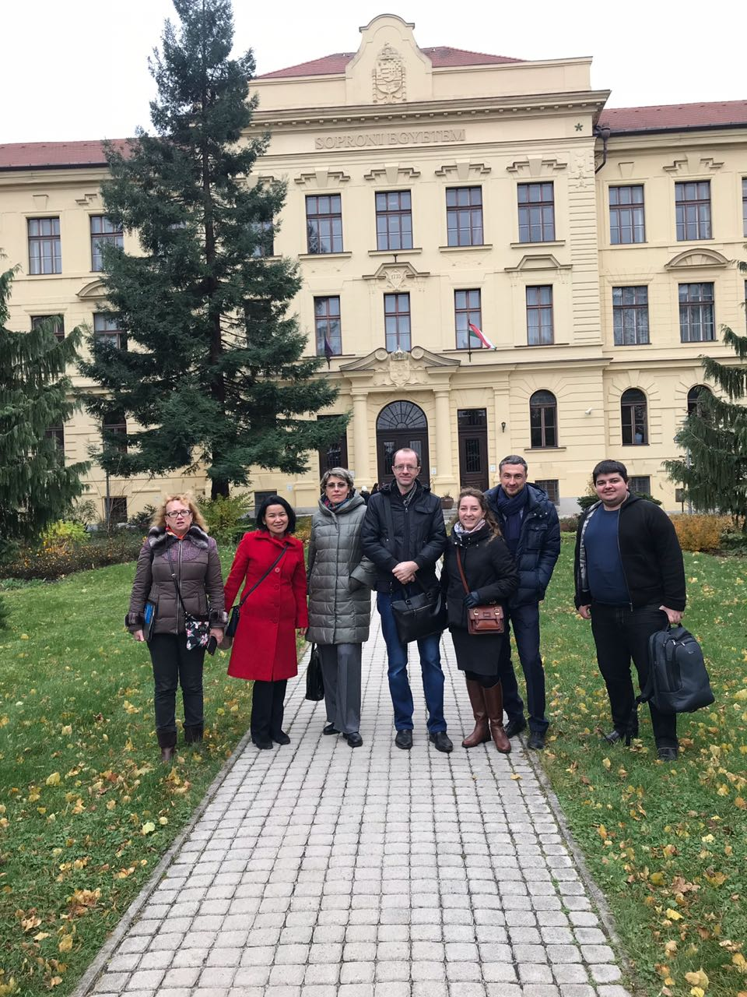
During our stage in Sopron, Hungary, the main training places were the University of Sopron (Alexandre Lamfalussy Faculty of Economics), the National Resources Research Center (NRCC), the University's research laboratories and the Management Center of one of the university's business partners - Gysev Railway. Acquaintance with the work of the university began with a visit to the Faculty of Economics.
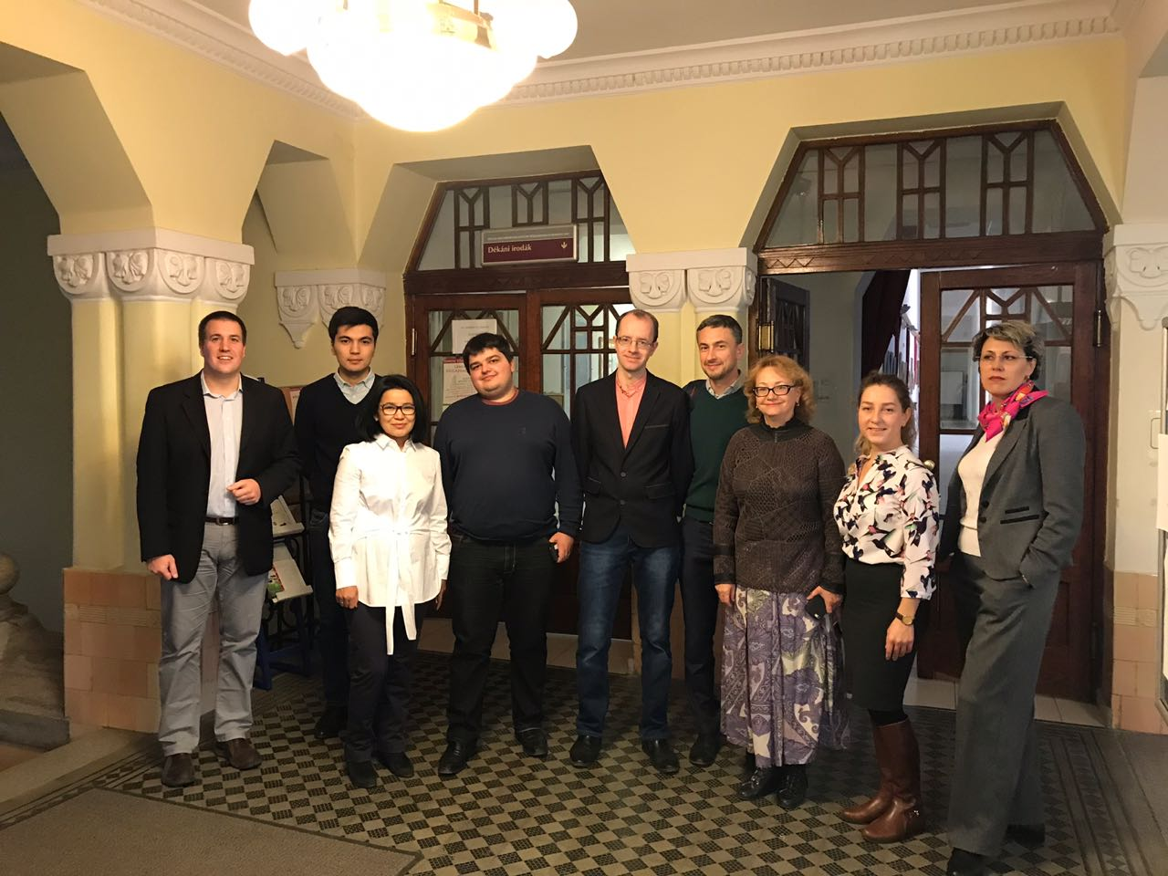
During the acquaintance to Faculty of Economics the participants received a brief description of the education system in Hungary and reviewed different programs of training at the University of Sopron. Dr. Tamas Czegledy presented his faculty and described in detail all programs implemented at the university. Also we had a discussion about the competitiveness of the economic faculty and the Hungarian higher education system itself. Much attention was paid to the organization of students' practice at the enterprises cooperating with the university.
On the same day we made a visit to the National Resources Research Center (NRCC), operating at the University of Sopron.
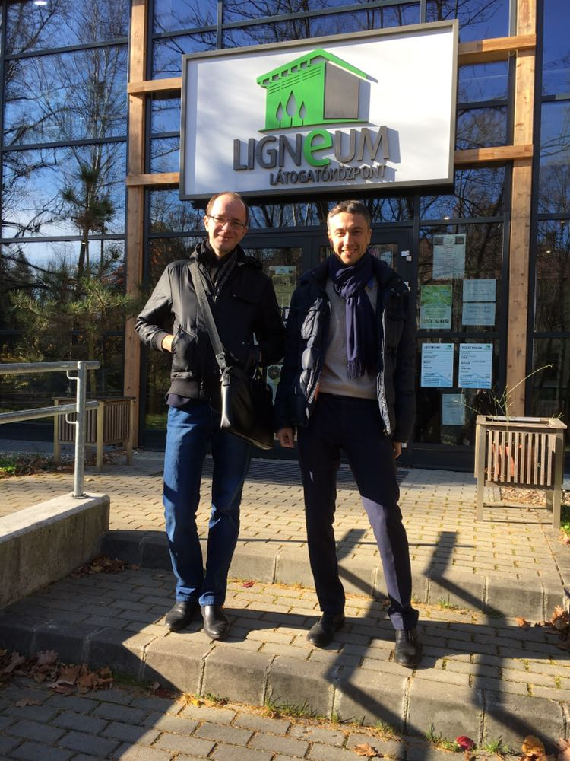
Dr. Denes Levente presented in detail the experience of building partnerships between the NRCC and different commercial organizations in Sopron. We took part in discussion about the principles of cooperation between commercial organizations and universities in Hungary. Special attention was given to some concrete examples of successful cooperation of the University of Sopron with large and small enterprises. Part of the training was held in the NRCC’s laboratories where we discussed some questions of involving students in research projects ordered by commercial organizations.
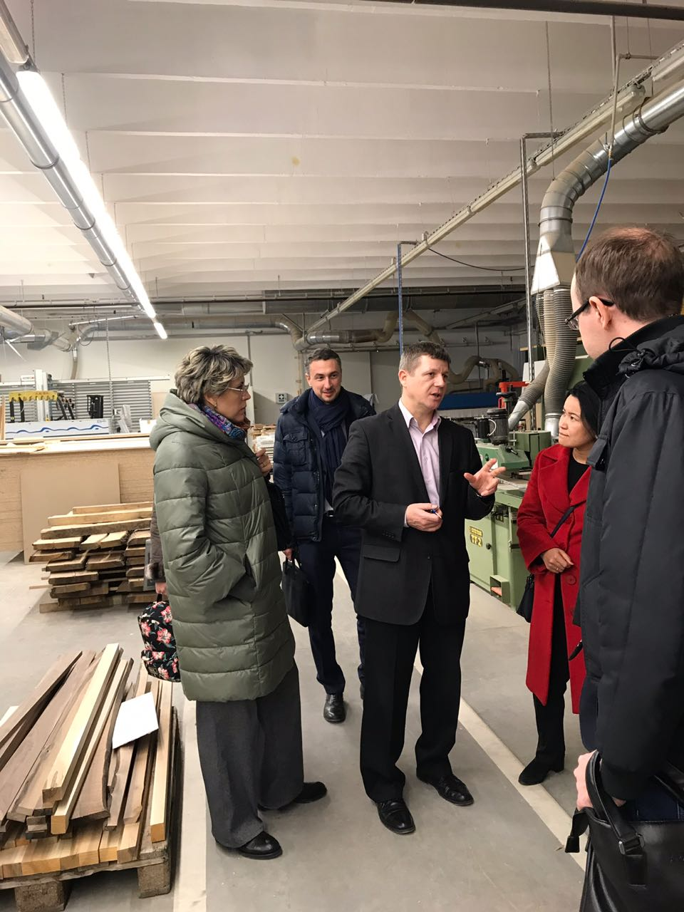

Then we visited the management center of Gysev railway transportation, one of the enterprises cooperating with the university. It is the main operating center for a list of railway stations near Sopron. Gysev railway station is an important university's business partner who have ordered some research made by the Faculty of Economics.
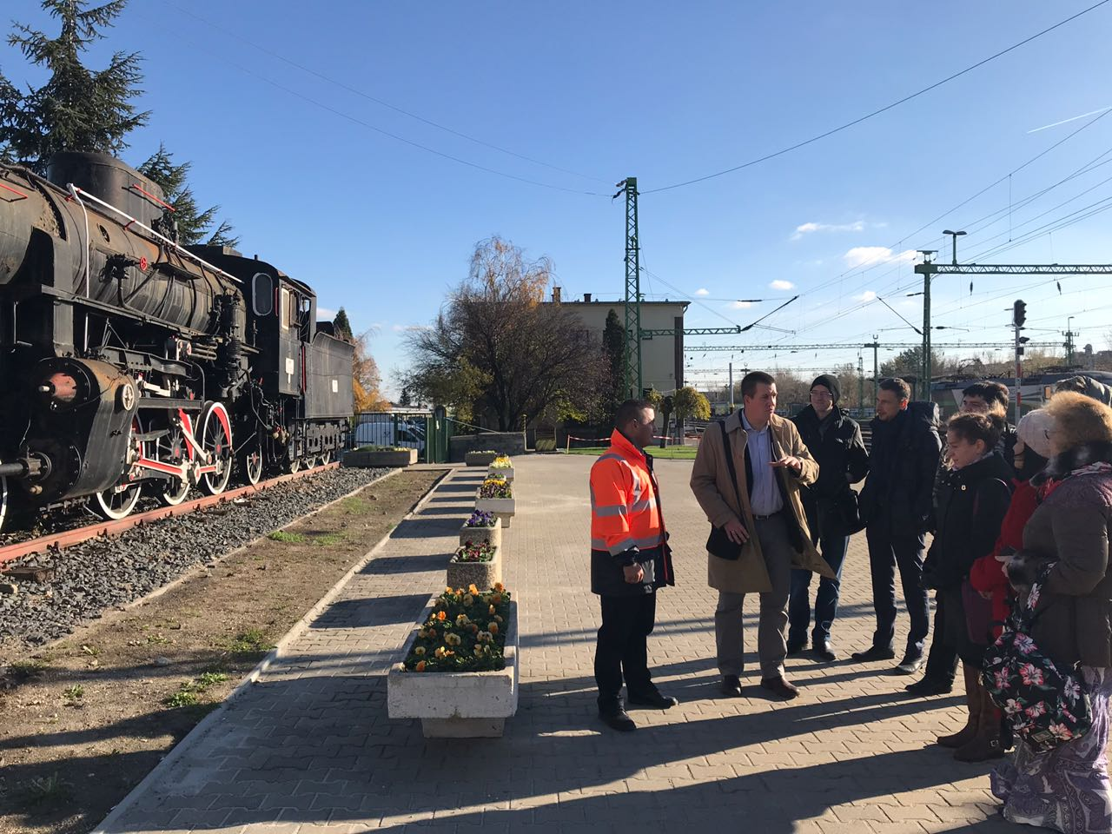
During the visit we have discussed such form of business cooperation as dual educational programs, based on the combination of traditional education and work in a partner company.
The training continued at the National Resources Research Center, where we discussed in detail various formats of university interaction with business partners. Our particular interest was given to Dr. Istvan Bartok who reviewed higher educational institutes and business cooperation programs held by the Faculty of Economics.
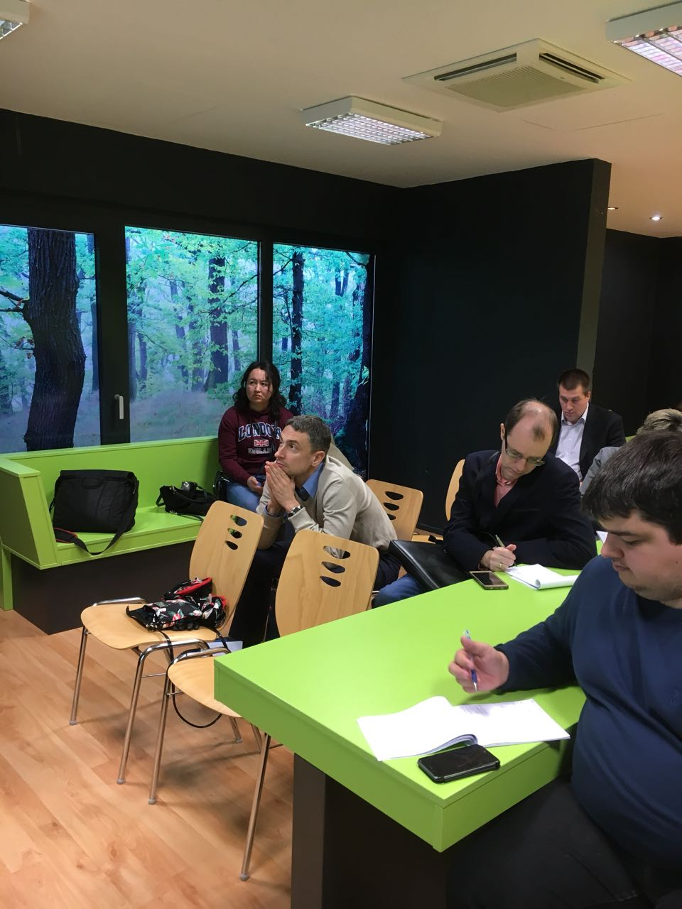
During the discussion of ways of interaction between higher education and business, we have highlighted the main differences between the Hungarian, Russian and Kazakhstani state systems of stimulating the development of cooperation between the university and commercial companies.
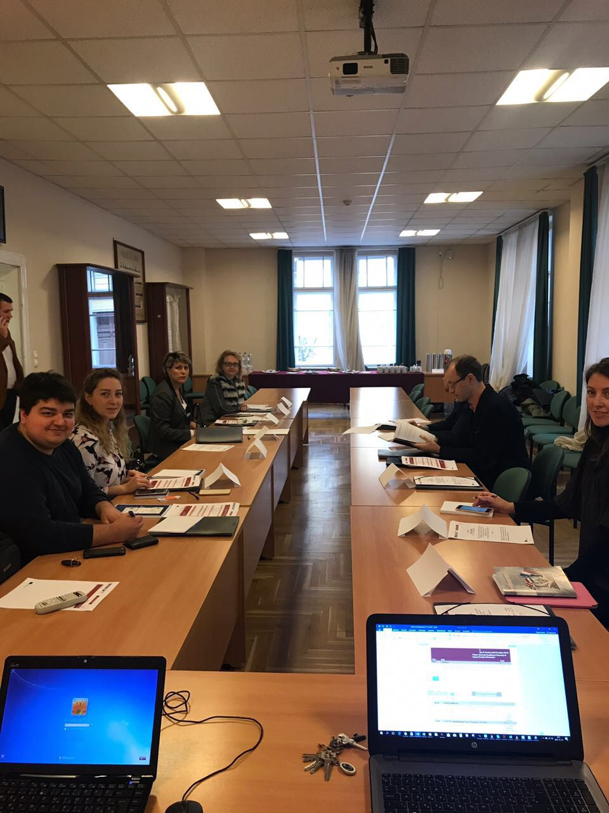
The peer-to-peer learning was organized at a high professional level. The receiving party has proved to be hospitable and highly skilled within the limits of discussed problems. Activities and events were actual and well organized, corresponded to the declared problems of stage.

