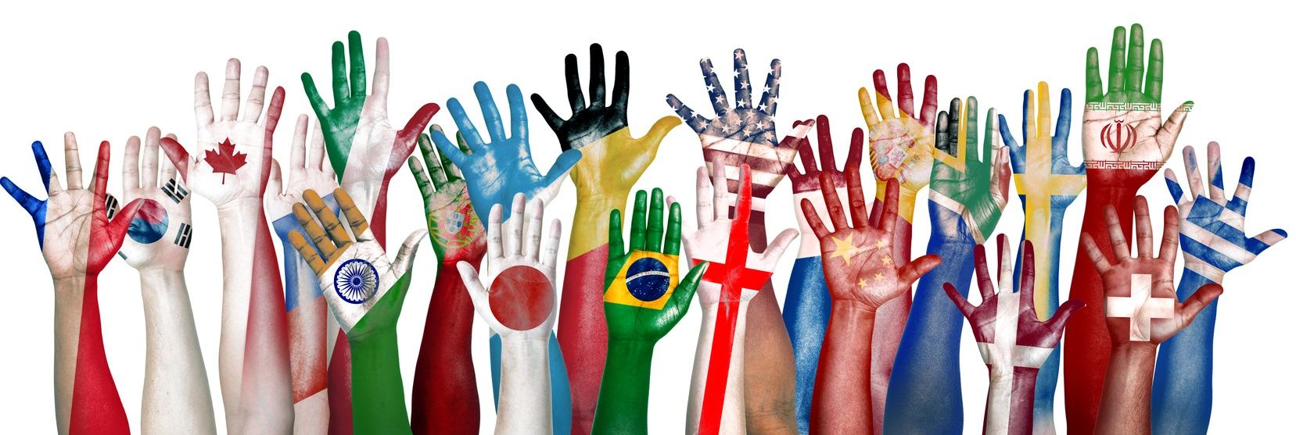

2nd INTERNATIONAL
BUSINESS – INTERCULTURAL SUMMER SCHOOL
SAMARA STATE UNIVERSITY OF ECONOMICS

August 05 - 18, 2019

Hosted by: International Department of Samara State University of Economics
Participants:
International students

Theme:
Development of international economic and cultural relations of Russia and Asian countries
Location:
Samara State University of Economics, Samara, Russia

Program

Breakfasts will be daily served from 8.15 till 8. 45.
 | 15. 07.  Monday |  | 16. 07.  Tuesday | 17.07.  Wednesday | 18.07.  Thursday | 19.07.  Friday | 20.07.  Saturday | 21.07.  Sunday
9.00 – 11. 00 | Opening Ceremony. Welcoming speech of Rector Khasaev G.  Meeting with lecturers and students of SSEU,  University guide |  | Russian as a foreign language (crash – class) | Lecture | Russian as a foreign language (crash – class) | Boat trip on Volga river  (Shiriaevo villige, National Park “Samarskaia Luka”), Repin Museum, Vdovin Museum | Lecture | Free time
9.00 – 11. 00 |  |  | Coffee -break | Coffee-break |  |  | Coffee-break | Free time
11.00 – 12.30 | Payment for program |  | Russian as a foreign language (crash – class) | Lecture | Russian as a foreign language (crash – class |  | Lecture | Free time
12.30 – 13.30 | Lunch at student’s cafe |  |  |  |  |  |  | Free time
13.30 | Samara City Round Tour | Art Museum  “East collection” |  | Visit to Pizzeria Bakery Production DODO | Samara cosmic  Museum |  | Exhibition “ My country is Russia”
 | 22. 07.  Monday | 23.07.  Tuesday |  | 24.07.  Wednesday | 25.07.  Thursday | 26.07.  Friday | 27.07.  Saturday | 28.07.  Sunday
9.00 – 10.30 | Stalin’s Bunker. | Lecture |  | Visit to Togliatti City (AvtoVAZ and Military – Technical Museum) | Russian as a foreign language (crash – class) | Lecture | Events according to participant’ wishes | Departure
10.30-11.00 | Coffee-break |  |  |  |  | Coffee-break |  | Departure
11.00 – 12.30 | Russian as a foreign language (crash – class) | Lecture |  |  |  | Lecture |  | Departure
12.30 – 13.30 | Lunch at student’s cafe |  |  |  | Lunch at student’s cafe |  |  | Departure
from 13.30 | Russian as a foreign language (crash – class) | Trade – Industry Chamber of Samara Region |  |  | Russian as a foreign language (crash – class) | Award ceremony,  Farewell Party,  Karaoke |  | Departure

Costs: 300 $ (lectures and workshops in English, breakfasts and lunches, excursions in English, factory’s visit, tuition, bus rent, certificates, transfer from and to the airport). The program is FREE OF CHARGE for 1 group leader pro 10 students.

Accommodation for 14 days is to be chosen:
1) on University’s campus – 134 $,
2) Hostel nearby the University - 183 $

List of excursions and visits included in the fee:
- Samara city round tour
- Samara Kosmicheskaia (Cosmic Samara)
- Trade – Industry Chamber of Samara Region
- Boat trip to Shiriaevo village (Volga trip) + visits to National park “Samarskaia luka”, Repin’s Museum, Vdovin’s Museum / Tsarev Kurgan
- Stalin’s Bunker
- Visit to Pizzeria Bakery Production DODO
- Samara Lakto Factory

List of excursions for additionally fees:
- Exhibition “ My country is Russia”, Mall Centre “Gudok”
- Art Museum “East collection”
- Military - Technical Museum of Avtovaz (Togliatti City)
- Wonderland Park Galileo
- Alabin’s Museum

The list of additional excursions will be offered to the participants by arrival.

After successful program completion the participants will be awarded with Certificates of Participation.

You are welcome at Samara State University of Economics!

Best regards,
International Department
Samara State University of Economics

Contact person:
Dr. Svetlana Komarova, Head of Foreign Students Support Department (International Department)
Email: sseu.international@gmail.com
Tel.: +7 846 933 86 86
www.sseu.ru

